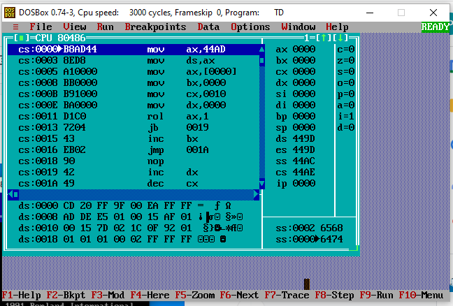

Before running

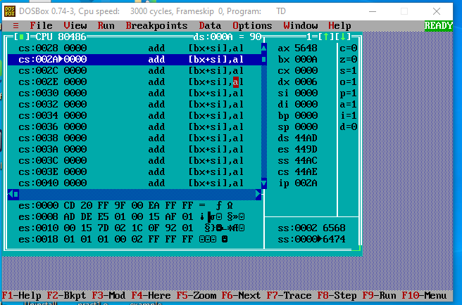

Code on notepad:

After running

Nos. of 0’s for 5648 : 8

Nos of 1’s for 5648:6

DATA SEGMENT

NO DW 0008H

Z DW ?

O DW ?

DATA ENDS

CODE SEGMENT

ASSUME CS:CODE, DS:DATA

START:

MOV AX, DATA

MOV DS, AX

MOV AX, NO

MOV BX, 00H

MOV CX, 10H

MOV DX, 00H

UP:

ROL AX,1

JC ONE

INC BX

JMP NXT

ONE:

INC DX

NXT:

DEC CX

JNZ UP

MOV Z, BX

MOV O, DX

INT 3

CODE ENDS

END START